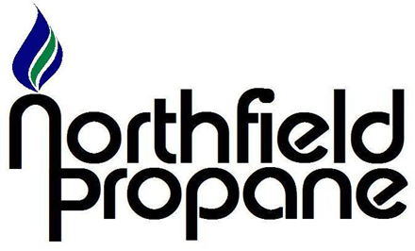

*No mobile information will be shared with third parties/affiliates for marketing/promotional purposes. All the above categories exclude text messaging originator opt-in data and consent; this information will not be shared with any third parties*

*SMS Terms and Conditions:*

*Product Description*

*By providing your mobile phone number, you consent to receive SMS messages from Northfield Propane related to your propane needs.*

*Message Frequency*

*Message frequency may vary.*

*Message and Data Rates*

*Standard message and data rates may apply depending on your carrier.*

*Opting Out*

*You may opt out of receiving SMS messages at any time by replying with "STOP" to any SMS message you receive from us. After opting out, you will receive a confirmation message, and we will cease sending SMS messages to your number.*

*Help and Support*

*If you need assistance or have questions about our SMS service, reply with "HELP" to any SMS message you receive, or contact our customer support team at (330) 227-8800*